How do you translate a webpage to Dutch?

It can occur that one visits a webpage on the internet written in a foreign language. If you want to translate the text to your mother language to be able to understand it, you act as follows:
Chrome
If you open a webpage written in a different language than your preferred languages in your settings, your browser Google Chrome will automatically prompt you to translate it.
First click to the right of the search bar at the top of the page, on the ‘translate’ .button.
Does this not work? Then click on an empty space on the page; with no image or text present, with your right mouse button. A dropdown menu will appear with the option ‘Translate page to Dutch’.
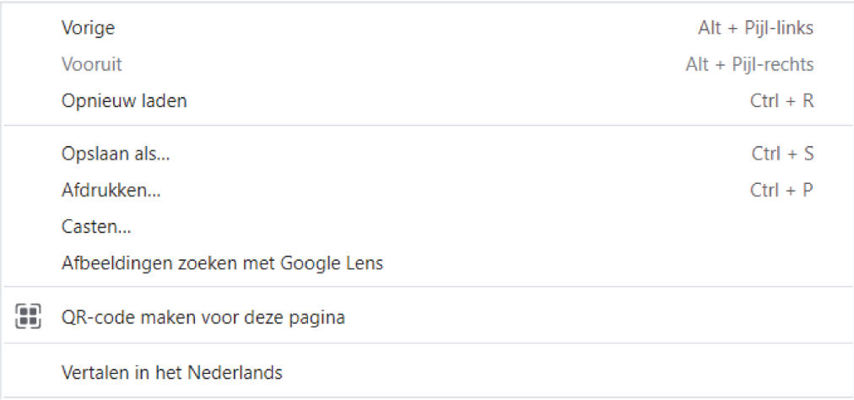
Clicking this button will translate the page to whatever language your browser is set to. Attention: This will be a literal translation of the text. Therefore, mistakes can occur in the grammar of the translation or in the interpretation.
Note: If you have previously used this function, Google Chrome starts automatically proposing to translate the page for you.
Changing the language of your Google Chrome-browser
Open Chrome and click on Meer Settings.
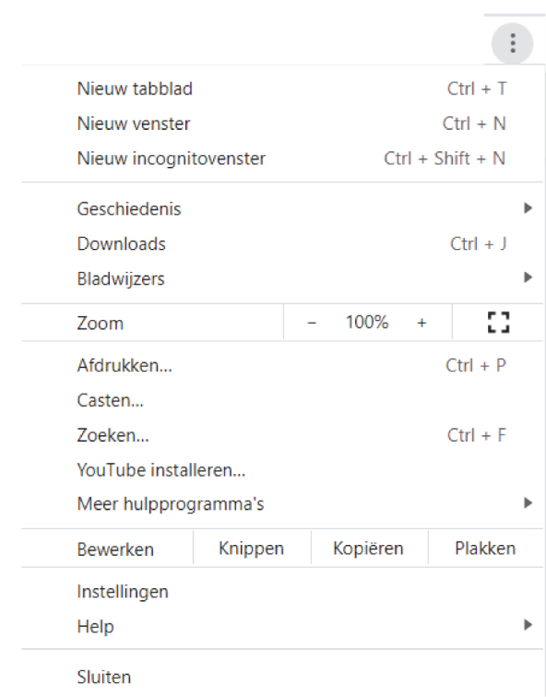
Click Languages. Language.
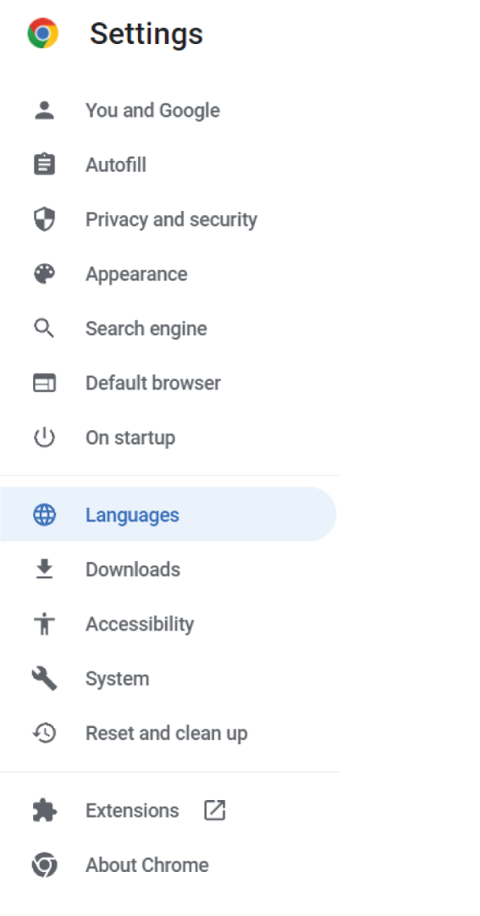
If this button is not available in the menu search for the advanced settings button
Next to the language you'd like to use, click More . ...
Click Display Google Chrome in this language. ...
Restart Chrome to apply the changes. 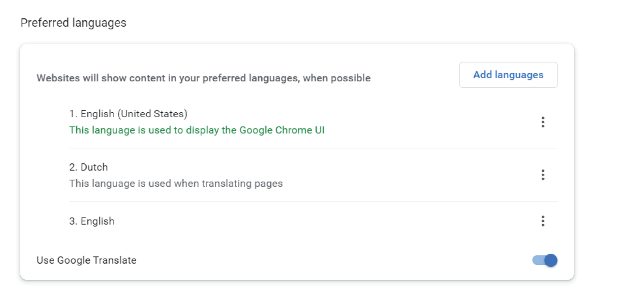
Microsoft Edge

Use Microsoft Translator in a Microsoft Edge browser
If you open a page written in a different language than your preferred languages in settings, Microsoft Edge will automatically prompt you to translate it.
The Translate icon appears in the address bar when you go to a web page that’s written in a foreign language. A language is considered foreign to you if it's not included in your Preferred languages list in your Settings. To add or remove languages from the list, in Microsoft Edge, go to Settings and more > Settings > Languages.

Translate a webpage in Microsoft Edge
- Open a webpage in Microsoft Edge. The browser will detect the language of the page and a menu will appear asking you to confirm that you want to translate the page.
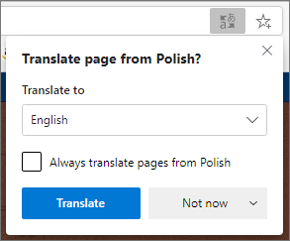

- Do any of the following:
  - In the Translate to dropdown, choose the language you want the page translated into. The default is the language you've set for Microsoft Edge.
  - To translate the page, click Translate.
  - To always automatically translate from the source language, select the Always translate from [Language] check box.
  - To skip translation, in the list on the lower right, select Not now to skip translation or Never translate [Language] to never have the panel appear when you go to a page using that language.
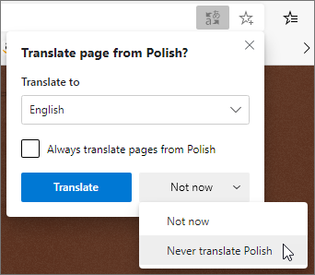
Note: You can manually return to this panel later, even if you select the option to Never translate.
- Inside the address bar, you'll briefly see the status showing that the page has been translated.

If you select the translate icon in the address bar, the menu that appears also shows the status.
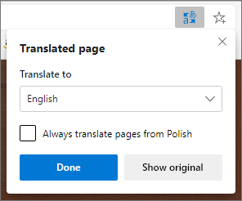

Manually translate webpage
If you've set Microsoft Edge to never translate a specific language, you won't see an automatic pop-up prompting you to translate. However, you'll still be able to translate it manually at any time.
To translate the page into a different language:
- Select the translate icon in the address bar.
- In the Translate to menu, select which language you want to translate to.
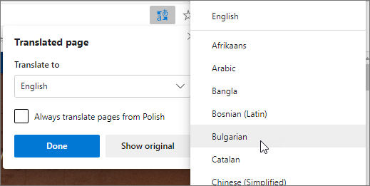
- Select Translate.

Revert translated webpage back to original language
- On the address bar, select the translate icon .
- Select the button Show original.
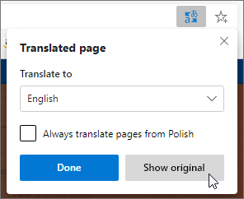

Turn translation in Microsoft Edge on or off
By default, Microsoft Edge will automatically prompt page translations.
To modify this setting:
- At the top corner of the browser, select Settings and more > Settings.
- Select Languages.
- Enable or turn off Offer to translate pages that aren't in a language I read.
By default, Microsoft Edge uses the same language as your system. For more information about using different languages in Microsoft Edge, learn how to use Microsoft Edge in another language.
Firefox
Firefox does not offer the ability to translate a page without extensions

